Project Design Phase
Solution Architecture
Team ID | [Enter your Team ID]
Project Name | Import Data using Transform Maps (Spreadsheet)

Solution Architecture:
Solution architecture is a complex process – with many sub-processes – that bridges the gap between business problems and technology solutions. Its goals are to:
- Find the best tech solution to solve existing business problems.
- Describe the structure, characteristics, behavior, and other aspects of the software to project stakeholders.
- Define features, development phases, and solution requirements.
- Provide specifications according to which the solution is defined, managed, and delivered.

Solution Architecture Diagram:
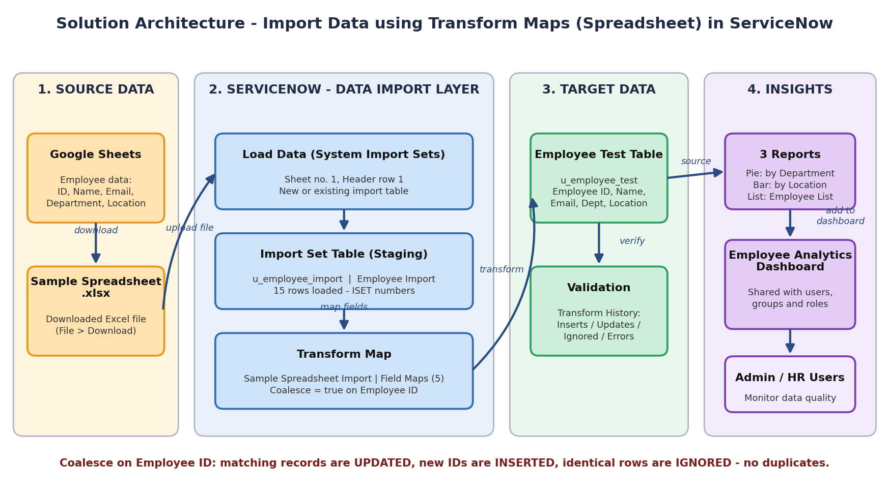
Figure 1: Architecture and data flow of the Import Data using Transform Maps project
Components and data flow:
- Source data: employee records (Employee ID, Name, Email, Department, Location) are prepared in Google Sheets and downloaded as Sample Spreadsheet.xlsx.
- Load Data: the Excel file is uploaded through System Import Sets > Load Data (Sheet 1, Header row 1) into the staging table u_employee_import.
- Transform Map: Sample Spreadsheet Import maps the 5 source fields to the target table Employee Test (u_employee_test); Coalesce is enabled on Employee ID.
- Transform and validate: running Transform inserts new records, updates matching ones and ignores unchanged rows; results are checked in Transform History.
- Reports and dashboard: three reports (Pie, Bar, List) are added to the Employee Analytics Dashboard, which can be shared with users, groups and roles.
Technology stack: ServiceNow platform (Tables, Import Sets, Transform Maps, Reports, Dashboards, ACL), Google Sheets / Microsoft Excel.

